**Assignment No. 4**

**KD1-Indrajeet-86641**

Q1. Write a select command that produces the order number, amount, and date for all rows in the Orders table.

🡺 **SELECT Onum, Amt, Odate FROM Orders;**

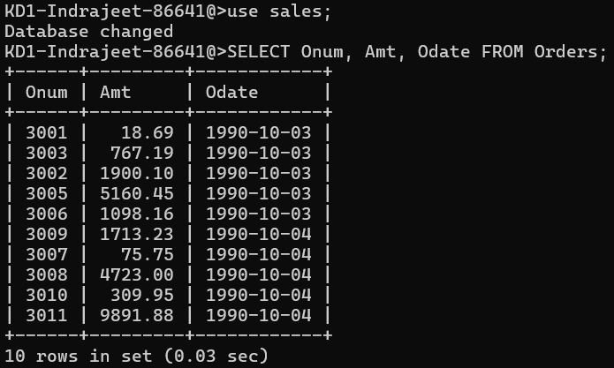

Q2. Write a query that produces all rows from the Customers table for which the salesperson’s number is 1001.

🡺 **SELECT * from Customers**

**Where Snum = 1001;**

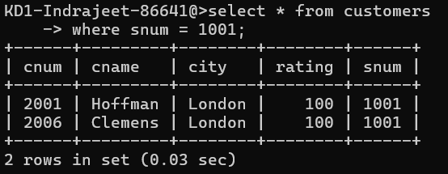

Q3. Write a query that displays the Salespeople table with the columns in the following order: city, sname, snum, comm.

🡺 **SELECT city, sname, snum, comm FROM Salespeople;**

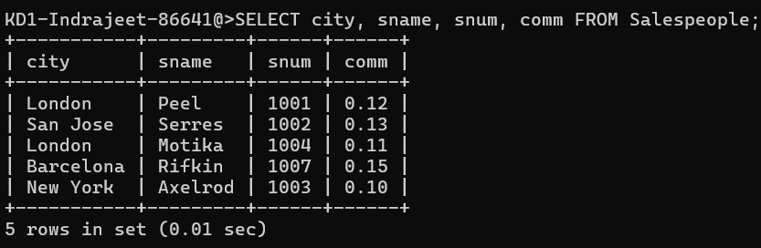

Q4. Write a select command that produces the rating followed by the name of each customer in San Jose.

🡺 **SELECT rating, cname FROM Customers**

**Where city = ‘San Jose’;**

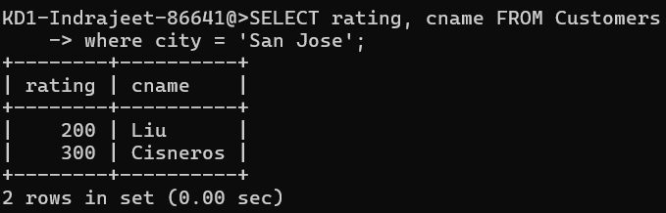

Q5. Write a query that will produce the snum values of all salespeople (suppress the duplicates) with orders in the Orders table.

🡺 **SELECT distinct snum from orders;**

